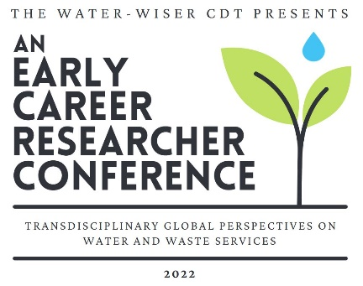
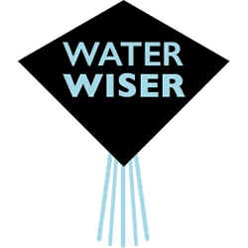

Abstract NO. XXX, 1st Water-WISER ERC Conference, Loughborough University 21 - 23 June 2022
Water-WISER presents: transdisciplinary global perspectives on water and waste services. An Early Career Researchers’ Conference
Author Name*, Author Name**, initials then surnames, separated by commas, appear here
*This is the first author’s address, email address
**This is the second author’s address, email address

Abstract: A short clear description of the main facts or ideas of your (outline) paper. This summary should not exceed 10 lines and should be inserted in the field on the first page in the area titled Abstract.

Keywords: Three keywords separated by; semi-colons

This is the first paragraph – text set with no indent. This is our preferred style for all first paragraphs after headings. [12pt Times New Roman]. Submissions are a maximum of two A4 pages inclusive of diagrams or illustrations. Your submission should include the background and nature of issue or problem, your findings and results, and the significance and impact of your presentation on the topic of the conference.
All subsequent paragraphs are indented. Your submission should include the background and nature of the issue or problem, your findings and results, and the significance and impact of your presentation on the topic of the conference.

Table 1.1 This is a style for Table Titles. “Table 1.1, 1.2 etc” should be in bold. Table captions should appear above tables.
Figure 1.1 This is a style for Figure legends. “Figure 1.1, 1.2 etc” should be in bold. Figure legends should appear below figures.

REFERENCES
Journal: Robson, A.J., Jones, T.A. & Reed, D.W. 1998 A study of national trend and variation in UK floods. Int. J. Climatol. 18, 165–182.

Book: McIntosh, A.C. 2003 Asian Water Supplies. IWA Publishing, London.
Edited book: Yoshida, Z. 1963 Physical properties of snow. In: Ice and Snow (W. Kingery, ed.). MIT Press, Cambridge, Massachusetts, USA, pp. 124–148.
Report: WWC 2000 A Water Secure World: Vision for Water, Life, and the Environment. Report of the World Water Council. World Water Council, Paris.

